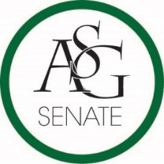
Senate Agenda
September 12th , 2017
Graduate Education Auditorium, 6:00 PM
- Call to Order
- Roll Call
- Approval of the Minutes
- Special Orders
  - Reports (5 minutes each)
    - Special Reports
    - Advisor, Michael McAllister
    - Graduate Assistants, Joshua Saraping and Sage McCoy
    - President, Andrew Counce
    - Vice-President, Natalie Counce
    - Treasurer, Macarena Arce
    - Secretary, Ashton Yarborough
    - Chief Justice, Cory English
      - Judicial Confirmations
    - GSC Speaker, Arley Ward
    - Cabinet Reports
      - Chief of Staff, JT Hale
    - FLF Coordinator, Abigail Walker
    - Chair of the Senate, Colman Betler
- Appointments, Nominations, and Elections
  - Engineering Caucus Chair Run-off
    - Ben Thornton
    - Allison Barnett
  - Swearing in of new senators
- Public Comment (3 at 2 minutes each)
- Old Business
  - ASG Senate Resolution No. 1 – The ASG Senate Standing Rules Act of 2017-2018
    - Authored by Chair of the Senate Colman Betler
    - Sponsored by Chair of the Senate Colman Betler
- New Business
  - ASG Budget 2017-2018
    - Authored by Treasurer, Macarena Arce
  - ASG Senate Resolution No. 2 - A Resolution to Reaffirm FLF
    - Authored by Senator Drake Moudy
    - Sponsored by Senator Jesse Kloss, Senator Clay Smith, and Senator Caroline Dallas
- Announcements
- Adjournment

