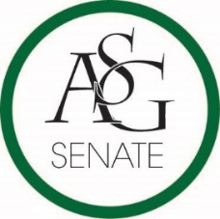
Senate Agenda
September 26th , 2017
Graduate Education Auditorium, 6:00 PM
- Call to Order
- Roll Call
- Approval of the Minutes
- Special Orders
  - Reports (5 minutes each)
    - Special Reports
    - Advisor, Michael McAllister
    - Graduate Assistants, Joshua Saraping and Sage McCoy
    - President, Andrew Counce
    - Vice-President, Natalie Counce
    - Treasurer, Macarena Arce
    - Secretary, Ashton Yarborough
    - Chief Justice, Cory English
    - GSC Speaker, Arley Ward
    - Cabinet Reports
      - Chief of Staff, JT Hale
    - FLF Coordinator, Abigail Walker
    - Chair of the Senate, Colman Betler
- Appointments, Nominations, and Elections
- Public Comment (3 at 2 minutes each)
- Old Business
  - ASG Budget 2017-2018
    - Authored by Treasurer, Macarena Arce
- New Business
  - ASG Joint Resolution No. 1 – The Old Main Oath Enshrinement Act
    - Authored by Co-Director of Academic Affairs Spencer Bone and GSC Speaker Arley Ward
    - Sponsored by Senator Clay Smith, Senator Jared Pinkerton, Senator Ben Thornton, Senator Warrington Sebree, Senator Jesse Kloss, Senator Kayla Kochan, Senator Josie DuBois, Senator Chase Arnold, Senator Drake Moudy, Senator Caroline Dallas, Senator Kianna Sarvestani, Senator Brandon Davis, GSC Representative Courtney Brooks
  - ASG Joint Resolution N0. 2 – Arkansas Union Food Court Expansion Act
    - Authored by Senator Josie DuBois, Director of External Relations Trevor Villines
    - Sponsored by GSC Representative Caleb Conrad, Senator Brittany Smith
- Announcements
- Adjournment

