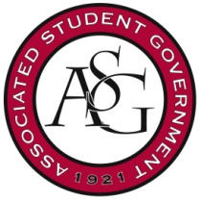
Associated Student Government
University of Arkansas

ASG Senate Bill No. 1
Author(s): Senator Jake Kyte
Sponsor(s): Senator Mackenzie Lantefield, Senator Parker Fitzgerald, Senator Katie Hicks, Vice President Morgan Farmer

The Chancellor’s Ball Funding Act of 2015

Whereas, The Associated Student Government of the University of Arkansas will continue the now annual tradition of hosting the Chancellor’s Ball for all students at the University of Arkansas; and

Whereas, The event will serve as a platform for the Associated Student Government to connect with the student body in a fun and engaging atmosphere that promotes school spirit and student unity; and

Whereas, The Executive team will also announce the 2015 Homecoming Court and present them with gifts from ASG at the event; and

Whereas, Expenses for the event will roughly equal the cost of last year’s event, with possible unpredictable “day-of” costs, the Executive body of this Student Government will need additional funds from the Senate legislative appropriations budget; then,

Be it therefore resolved: The Associated Student Government Senate allocates $2,000.00 from the Senate legislative appropriations budget to help fund the event’s expenses.

Official Use Only

Amendments:

Vote Count: Aye Nay Abstentions

Legislation Status: Passed Failed Other

___________________________ ________________
Jace Motley, ASG Chair of the Senate Date

___________________________ ________________
Tanner Bone, ASG President Date

