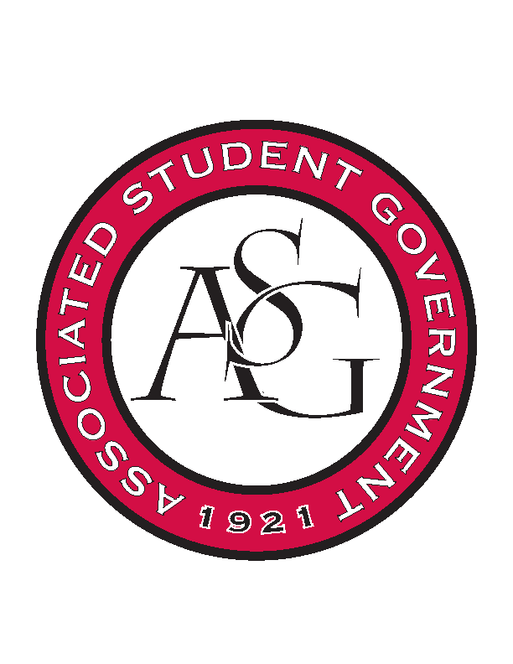
Associated Student Government

Office of Financial Affairs Meeting Agenda
August 24, 2017

- Call To Order
- Roll Call
  - Board Introductions
- Approval of the Minutes
- Audit Reports
- Old Business
- New Business
- Announcements
  - Updated Standing Rules, Funding Guide and Funding Application
  - Funding Date Tab
  - HogSync
  - Pictures
- Adjournment

