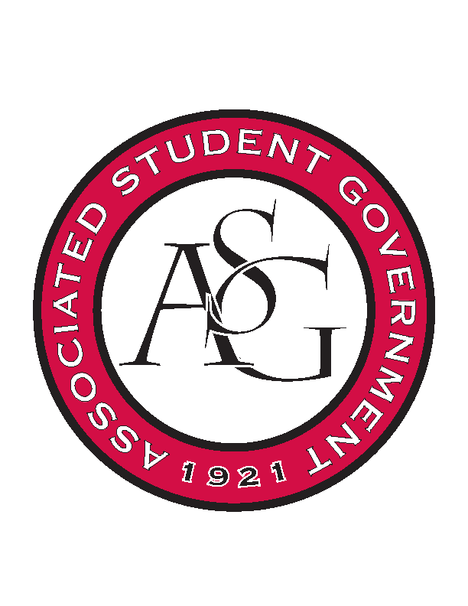
Associated Student Government

Office of Financial Affairs Meeting Agenda
August 31, 2017

- Call To Order
- Roll Call
- Approval of the Minutes
- Audit Reports
- Old Business
- New Business
  - Electrochemical Society, U of A Student Chapter
  - Pre-Law Society
  - The Higher Education Organization
  - Biomedical Engineering Society
  - Speech and Debate Society
  - Celtic Culture Society
  - Contemporary Sculpture Society
  - Alpha Kappa Delta
  - Il Circolo Italiano
  - Biology Graduate Student Association
- Announcements
- Adjournment

