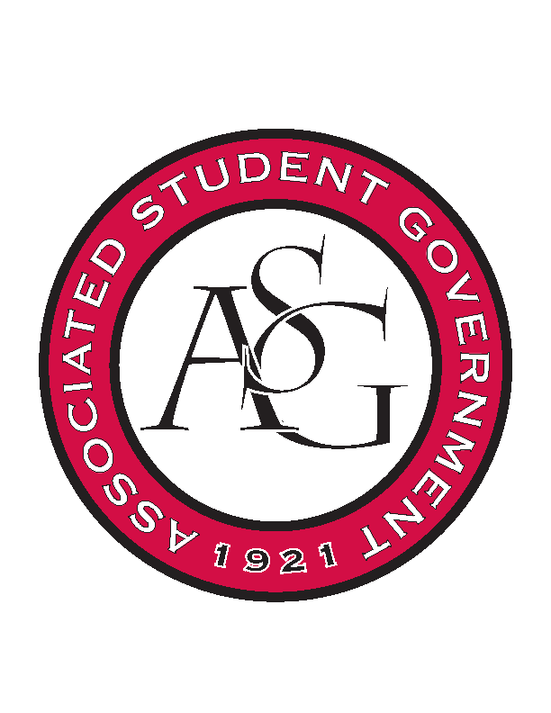
Associated Student Government

Office of Financial Affairs Meeting Agenda
August 24, 2017

- Call To Order 4:59
- Roll Call
  - Adam Jones
  - Andrew Estes
  - Colin Gonzalez
  - Jalen Hemphill
  - Kyle Ward
  - Nathan Smith
      - absent
  - Peyton Podschwit
  - Semien Hagos
  - Sofia Hadley
Proxies
  - Kadarius Toussaint
  - Kate Hedgecock
  - Madeline Brown
  - William Neely
- Approval of the Minutes
- Audit Reports
- Old Business
- New Business
- Announcements
  - Updated Standing Rules, Funding Guide and Funding Application
      - OFA Overview Presentation
  - HogSync
      - Fill out audit through HogSync
  - Pictures
- Adjournment
  - 5:42

