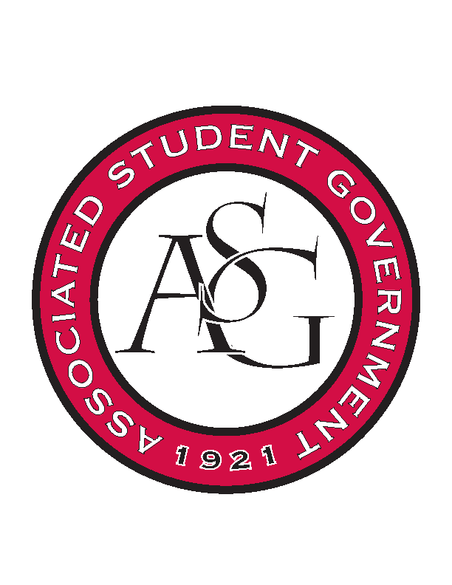
Associated Student Government

Office of Financial Affairs Meeting Agenda
September 14, 2017

- Call To Order
- Roll Call
- Approval of the Minutes
- Audit Reports
- Old Business
  - Japanese Students Association
  - Technology and Engineering Education Collegiate Association
  - Engineering Safety
  - Eta Sigma Phi Beta Chapter
- New Business
  - Society for Women Engineering
  - Spoon University Recruitment
  - Spoon University Event
  - Lambda Alpha Epsilon
  - Razorback Booster Club Auburn
  - Razorback Booster Club Homecoming
  - Caribbean Students Association
  - Simple Truth
  - National Association for Music Education
  - Business Law Society
- Announcements
  - ASG Retreat September 17 12:30 – 4:00 pm
- Adjournment

