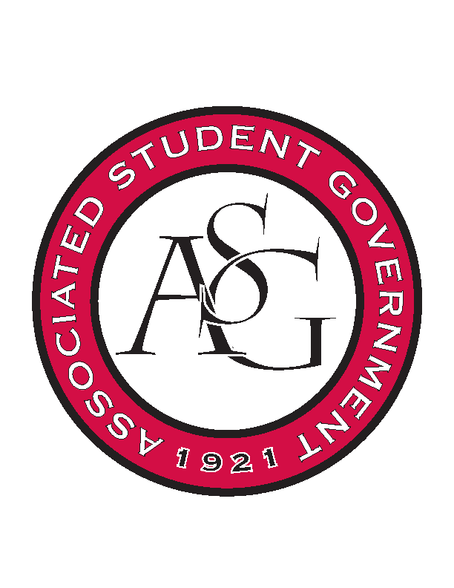
Associated Student Government

Office of Financial Affairs Meeting Agenda
September 7, 2017

- Call To Order
  - 4:59pm
- Roll Call
  - Adam Jones
  - Andrew Estes
  - Colin Gonzalez
  - Jalen Hemphill
  - Kyle Ward
  - Kadarius
  - Peyton Podschwit
  - Semien Hagos
  - Sofia Hadley
Proxies
  - Kate Hedgecock
  - Madeline Brown
  - William Neely
  - Ploy Pleetissamuth
- Approval of the Minutes
- Audit Reports
- Old Business
  - Electrochemical Society, U of A Student Chapter
      - Second Round Approved 9-0
  - Pre-Law Society
      - Second Round Approval 9-0
  - The Higher Education Organization
      - Second Round Approval 8-1
  - Biomedical Engineering Society
      - Second Round Approval 9-0
  - Speech and Debate Society
      - Second Round Approval 9-0
  - Celtic Culture Society
      - Amount Change Denied 8-1
      - Second Round Approved 6-3
  - Contemporary Sculpture Society
      - Second Round Approval 9-0
  - Alpha Kappa Delta
      - Second Night Denied 9-0
      - Second Round Approval 9-0
  - Il Circolo Italiano
      - Film Rights Added
      - Second Round Approval 9-0
  - Biology Graduate Student Association
      - Second Round Approval 9-0
- New Business
  - Japanese Students Association
      - Orange Juice $6?
      - Green Tea $20
      - Paper plates can be cheaper
      - First Round Approved 9-0
  - Technology and Engineering Education Collegiate Association
      - Found the cost but can’t find when it’s due?
      - First Round Approved 9--0
  - Russian-Eurasian Student Organization
      - Denied 9-0
  - Engineering Safety
      - First Round Approved 9-0
  - Eta Sigma Phi Beta Chapter
      - Why do you need two nights?
      - Is the lecture at a different hour?
      - Where are the desserts from?
      - Why is it necessary to move it to Carnall Hall?
      - Does the food have to be from Carnall Hall?
      - Motion to table failed
      - First round approved 5-4
- Announcements
  - Ordering card scanners
- Adjournment
  - 5:53pm

