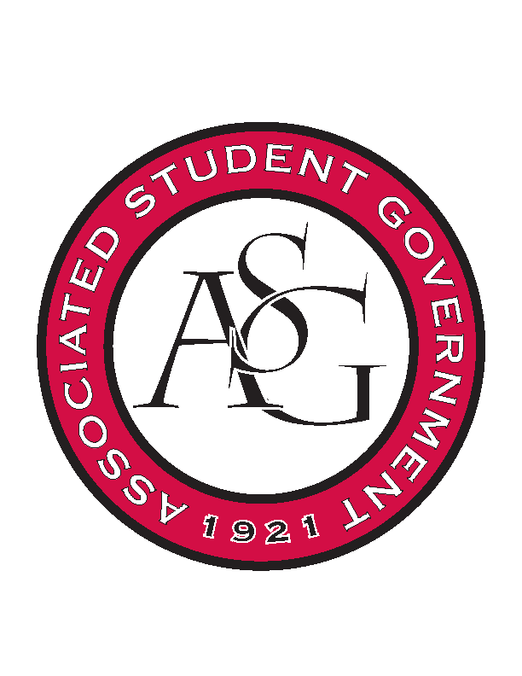
Associated Student Government

Office of Financial Affairs Meeting Agenda
October 12, 2017

- Call To Order
- Roll Call
- Approval of the Minutes
- Audit Reports
- Appeals
  - Printmaking Club
- Old Business
  - Panamanian Student Organization
  - Bangladesh Student Organization
  - Tau Beta Pi
  - African Students Organization
  - Students for Refugees
  - Millicent Gikunda
  - Iranian Students Association
  - ASCEND-University of Arkansas Student Chapter
- New Business
  - Il Circolo Italiano (Italian Club)
  - Criminal Law Society
  - Chi Alpha
  - Hmong Student Organization of Arkansas
  - International Students Organization
  - Black Law Students Association
  - NCTE 9 Individual Budgets
  - Camp Kesem at University of Arkansas
  - Electrochemical Society, UofA Student Chapter
  - Students of Retailing Excellence
- Announcements
  - Next Funding Session October 11
  - Don’t forget to do audits!
- Adjournment

