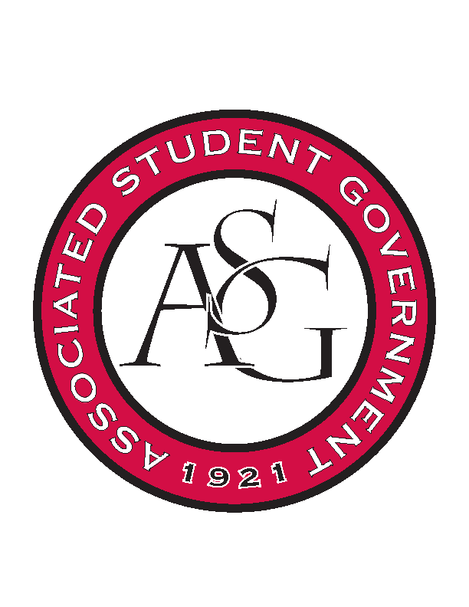
Associated Student Government

Office of Financial Affairs Meeting Agenda
October 19, 2017

- Call To Order
- Roll Call
- Approval of the Minutes
- Audit Reports
- Appeals
- Old Business
  - Il Circolo Italiano (Italian Club)
  - Chi Alpha
  - Hmong Student Organization of Arkansas
  - International Students Organization
  - Black Law Students Association
  - NCTE 9 Individual Budgets
  - Camp Kesem at University of Arkansas
  - Electrochemical Society, UofA Student Chapter
  - Students of Retailing Excellence
- New Business
  - Fulbright Scholars at the University of Arkansas
  - You Ought to Live Optimistically
  - Advertising Club
  - Drawing and Painting Association
  - Student Sierra Coalition at the University of Arkansas
- Announcements
  - Next Funding Session October 24
  - Don’t forget to do audits!
- Adjournment

