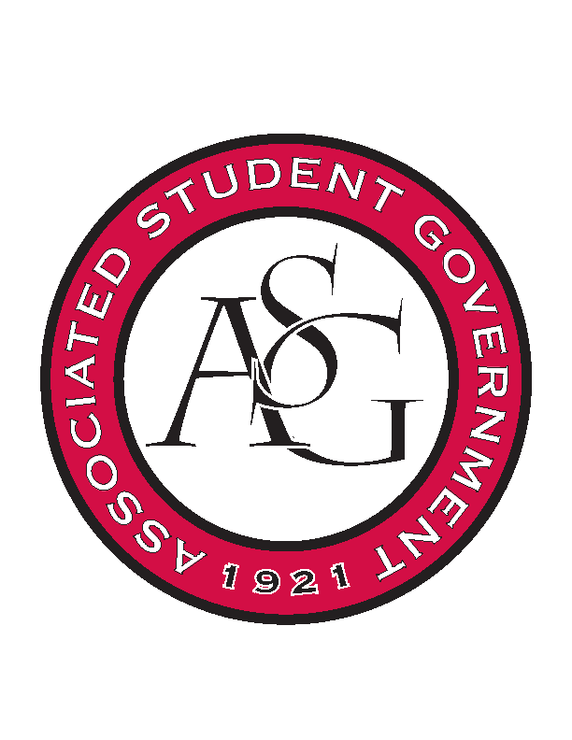
Associated Student Government

Office of Financial Affairs Meeting Agenda
October 5, 2017

- Call To Order
- Roll Call
- Approval of the Minutes
- Audit Reports
- Appeals
- Old Business
  - University of Arkansas Art Educators Association Conference 1 and 2
  - American Society of Civil Engineers
  - Eta Sigma Delta
  - Full Stomachs Clean Feet
  - Pre-Law Society
  - The Higher Education Organization
  - West Coast Swing
  - Phi Beta Sigma Fraternity Inc.
  - Russian-Eurasian Student Organization
  - Net Impact
- New Business
  - Panamanian Student Organization
  - THEO Abby Blumberg NIRSA
  - Bangladesh Student Organization
  - Printmaking Club
  - Tau Beta Pi
  - African Students Organization
  - Students for Refugees
  - Millicent Gikunda
  - Iranian Students Association
  - ASCEND-University of Arkansas Student Chapter
- Announcements
  - Next Funding Session October 11
  - Don’t forget to do audits!
- Adjournment

