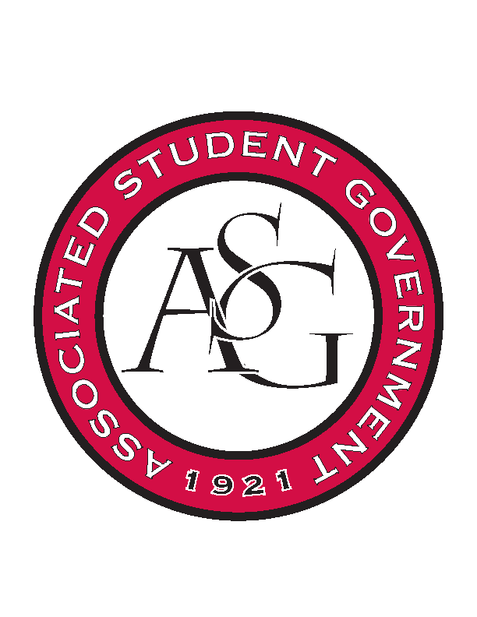
Associated Student Government

Office of Financial Affairs Meeting Agenda
September 28, 2017

- Call To Order
- Roll Call
- Approval of the Minutes
- Audit Reports
- Appeals
  - Simple Truth
- Tabled
  - Lambda Alpha Epsilon
- Old Business
  - Panamanian Student Organization
  - Native American Student Association UA
  - Graduate Students in English
  - Hindu Students Association
  - Biology Club
  - UARK Gaming
- New Business
  - University of Arkansas Art Educators Association Conference 1 and 2
  - University of Arkansas Art Educators Association Event
  - Pi Sigma Alpha
  - American Society of Civil Engineers
  - Eta Sigma Delta
  - Theta Tau Upsilon Chapter
  - Full Stomachs Clean Feet
  - Pre-Law Society
  - The Higher Education Organization
  - Pre-Veterinary Club
  - West Coast Swing
  - Phi Beta Sigma Fraternity Inc.
  - Russian-Eurasian Student Organization
  - Student Congress at the University of Arkansas
  - Net Impact
- Announcements
  - Next Funding Session October 11
  - Don’t forget to do audits!
- Adjournment

