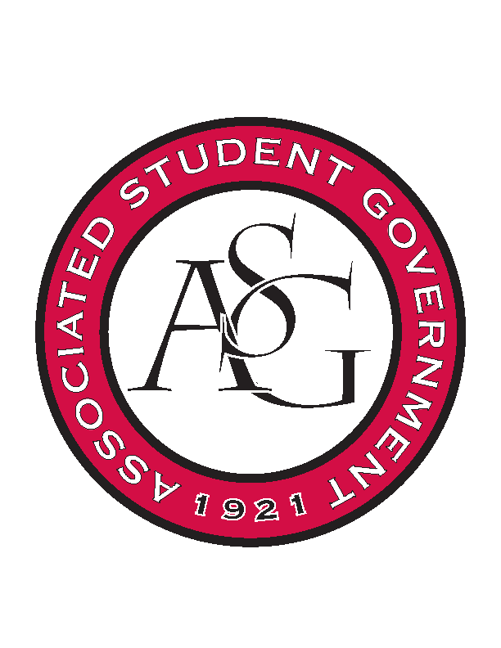
Associated Student Government
Office of Financial Affairs Meeting Agenda
October 26, 2017

- Call To Order
- Roll Call
  - Adam Jones
  - Andrew Estes
  - Colin Gonzalez
  - Jalen Hemphill
  - Kyle Ward
  - Kadarius
  - Peyton Podschwit
  - Semien Hagos
  - Sofia Hadley
Proxies
  - Kate Hedgecock
  - Madeline Brown
  - William Neely
  - Ploy Pleetissamuth -

- Approval of the Minutes
- Audit Reports
- Appeals
  - Friends of India
- Old Business
  - Fulbright Scholars at the University of Arkansas
      - Made some adjustments to budget
      - Second round approved (9-0)
  - You Ought to Live Optimistically
      - Second Round Approved (9-0)
  - Advertising Club
      - The event is PM
      - Chartwells is providing silverware
      - Will cut coffee to 1 to decrease price per head
      - Cut silverware- may appeal if they want it back
      - Second round approved (9-0)
  - Drawing and Painting Association
      - Second round approved (9-0)
  - Student Sierra Coalition at the University of Arkansas
      - Second round approved (8-0-1)
- New Business
  - Badminton Club
      - Approved (9-0)
  - Hogs End Alz
      - Approved (9-0)
  - Non-traditional Premedical Student Organization
      - What are the drinks?
      - Where is the pizza from?
      - Approved (9-0)
  - Association of Ceramic Enthusiasts
      - Approve (9-0)
  - Friends of India
      - Denied (8-1)
  - Space and Planetary Association for Collaboration and Education Hogs
      - Denied (8-1)
  - The Higher Education Organization
      - Confirm the conference dates
      - Approved (9-0)
- Announcements
  - Don’t forget to do audits!
- Adjournment

