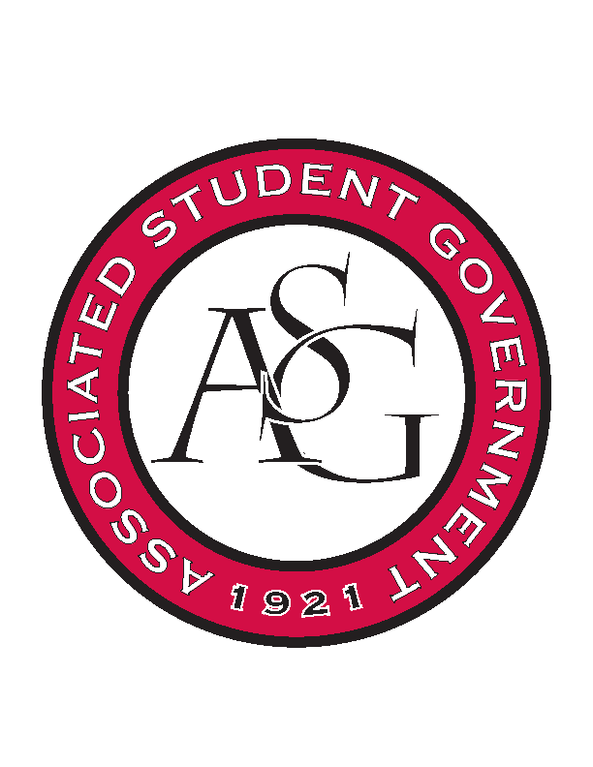
Associated Student Government

Office of Financial Affairs Meeting Agenda
September 28, 2017

- Call To Order
- Roll Call
  - Adam Jones
  - Andrew Estes
  - Colin Gonzalez
  - Jalen Hemphill
  - Kyle Ward
  - Kadarius
      - Proxy Ploy Pleetissamuth
  - Peyton Podschwit
  - Semien Hagos
      - Proxy William Neely
  - Sofia Hadley
Proxies
  - Kate Hedgecock
  - Madeline Brown
  - William Neely
  - Ploy Pleetissamuth

- Approval of the Minutes
- Audit Reports
- Appeals
  - Simple Truth
      - Stated the purpose of RSO.
      - Who is receiving this money? For a student at the U of A.
      - We have 5 members that go to the U of A. (all RSOs have to have 6 students).
      - Student unsure of who their faculty/staff advisor.
      - 9-0 denied
- Tabled
  - Lambda Alpha Epsilon
      - Follow up that students can go but if they earn the award, it needs to go to the RSO not the individual.
      - 9-0 approved (second round)
- Old Business
  - Panamanian Student Organization
      - 9-0 approved
  - Native American Student Association UA
      - Approved 9-0 –Chartwells Pappa John’s Pizza @ $50 total
  - Graduate Students in English
      - Changed to Eureka – no tip;
      - changed to $6 per pizza (7 pizzas)
      - 9-0 approved
  - Hindu Students Association
      - 9-0 approved
  - Biology Club
      - What is the movie? Popcorn from Wal-Mart
      - 9-0 approved
  - UARK Gaming
      - 9-0 approved (review canned drinks rule for future Standing Rules) 9-0 approved
- New Business
  - University of Arkansas Art Educators Association Conference 1 and 2
      - Conference 1 – National Art Conference – Seattle – 9-0 approved
      - Conference 2 - Arkansas Art Education – 9-0 approved
  - University of Arkansas Art Educators Association Event
      - Too early (remind that to reapply)
      - 9-0 denied
  - Pi Sigma Alpha
      - no name, pizza too much, incomplete budget
      - 9-0 denied
  - American Society of Civil Engineers
      - Networking event – cut non-students from 20 to 15, where are you getting food, good audit opportunity.
      - Can you please elaborate on educational aspects?
      - 9-0 approved
  - Eta Sigma Delta
      - Discussed educational value of the conference
      - 9-0 approved
  - Theta Tau Upsilon Chapter
      - Where’s the due date for conference?
      - No perceived educational value.
      - 9-0 denied
  - Full Stomachs Clean Feet
      - 9-0 approved
  - Pre-Law Society
      - 9-0 approved
  - The Higher Education Organization
      - 9-0 approved
  - Pre-Veterinary Club
      - The conference isn’t open, no due date, reapply when the conference website. Table moti0n
      - 6-3 tabled until 11/15
  - West Coast Swing
      - Where are you getting your food?
      - 9-0 approved
  - Phi Beta Sigma Fraternity Inc.
      - 7-2 approved
  - Russian-Eurasian Student Organization
      - Discussion regarding the sale of merchandise.
      - 8-1 approved
  - Student Congress at the University of Arkansas
      - No website. Deadline we found makes this budget late.
      - 8-1 denied
  - Net Impact
      - 9-0 approved
- Announcements
  - Next Funding Session October 11
  - Don’t forget to do audits!
- Adjournment

