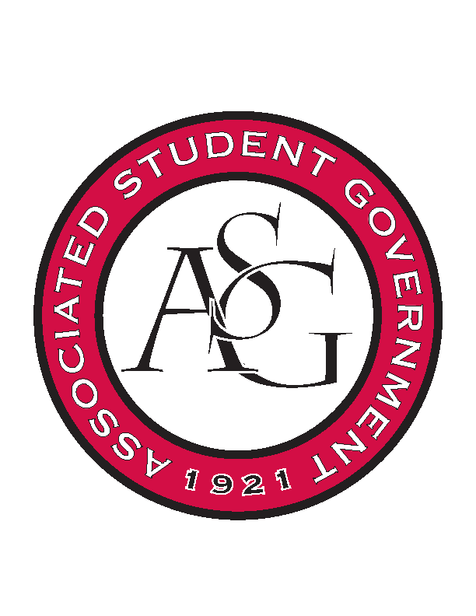
Associated Student Government

Office of Financial Affairs Meeting Agenda
November 16, 2017

- Call To Order
- Roll Call
- Approval of the Minutes
- Appeals
- Audit Reports
- Tabled Budgets
  - Pre-Veterinary Club
- Old Business
  - Chinese Students and Scholars Association
  - Arkansas Women in Statistics and Mathematics
- New Business
  - Alpha Epsilon Delta
  - Printmaking Club – Conference
  - Lambda Alpha Epsilon
  - Printmaking Club – Event
  - Hogs End Alz
- Standing Rules Meeting
- Announcements
  - Don’t forget to do audits!
- Adjournment

