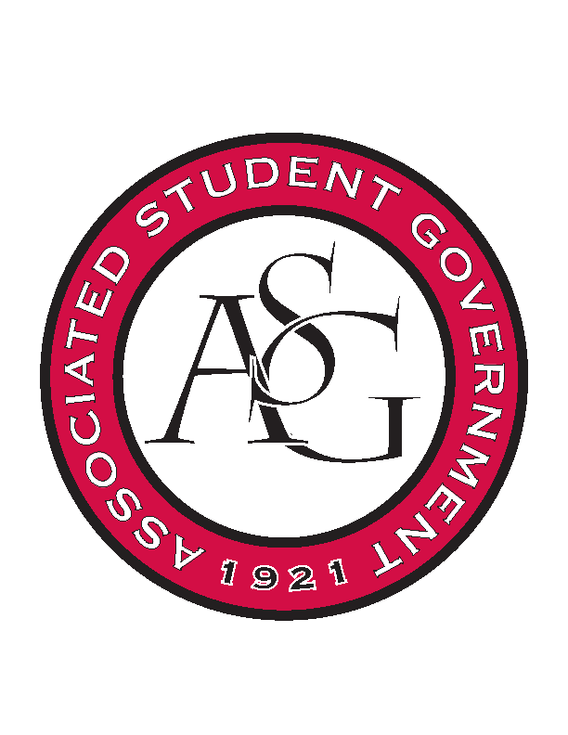
Associated Student Government

Office of Financial Affairs Meeting Agenda
November 2, 2017

- Call To Order
- Roll Call
- Approval of the Minutes
- Audit Reports
- ASG Constitution Committee Nominations
- Appeals
- YOLO $60.85
- Old Business
  - Badminton Club
  - Hogs End Alz
  - Non-traditional Premedical Student Organization
  - Association of Ceramic Enthusiasts
  - The Higher Education Organization
- New Business
  - Geo-Institute Graduate Student Organization
  - Korean Food Cooking Club
  - Agricultural Communicators of Tomorrow
  - Alpha Kappa Psi
  - Contemporary Sculpture Society
  - Students of Retailing Excellence
- Announcements
  - Don’t forget to do audits!
  - Funding Sessions Nov 8 and 14
  - Standing Rules meeting November 9!
- Adjournment

