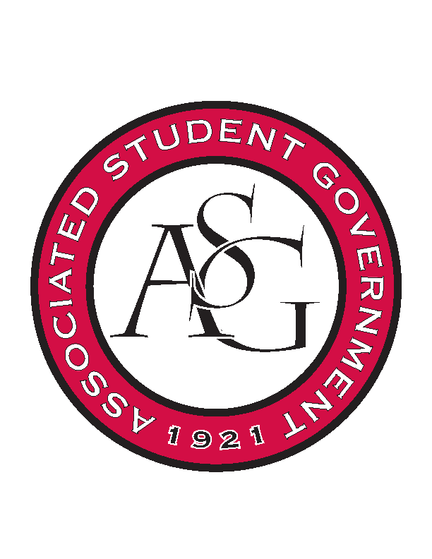
Associated Student Government

Office of Financial Affairs Meeting Agenda
November 30, 2017

- Call To Order
- Roll Call
- Approval of the Minutes
- Appeals
- Audit Reports
- Old Business
  - Alpha Epsilon Delta
  - Printmaking Club – Conference
  - Lambda Alpha Epsilon
  - Printmaking Club – Event
  - Hogs End Alz
- New Business
  - Biomedical Engineering Society
  - Chi Epsilon
  - Horticulture Club
  - Kappa Kappa Psi
  - American Constitution Society
- Announcements
  - Don’t forget to do audits!
  - OFA White Elephant
- Adjournment

