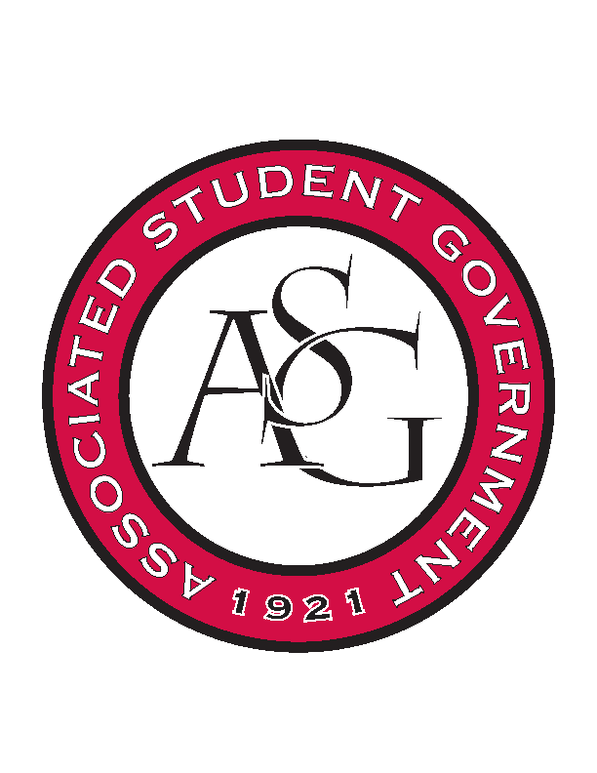
Associated Student Government

Office of Financial Affairs Meeting Agenda
November 9, 2017

- Call To Order
- Roll Call
- Approval of the Minutes
- Appeals
  - Students of Retailing Excellence
- Audit Reports
- ASG Constitution Committee Nominations
- Old Business
  - Geo-Institute Graduate Student Organization
  - Korean Food Cooking Club
  - Agricultural Communicators of Tomorrow
  - Alpha Kappa Psi
  - Contemporary Sculpture Society
- New Business
  - Chinese Students and Scholars Association
  - Arkansas Women in Statistics and Mathematics
  - Reformed University Fellowship
- Standing Rules Meeting
- Announcements
  - Don’t forget to do audits!
  - Funding Session Nov 14
- Adjournment

