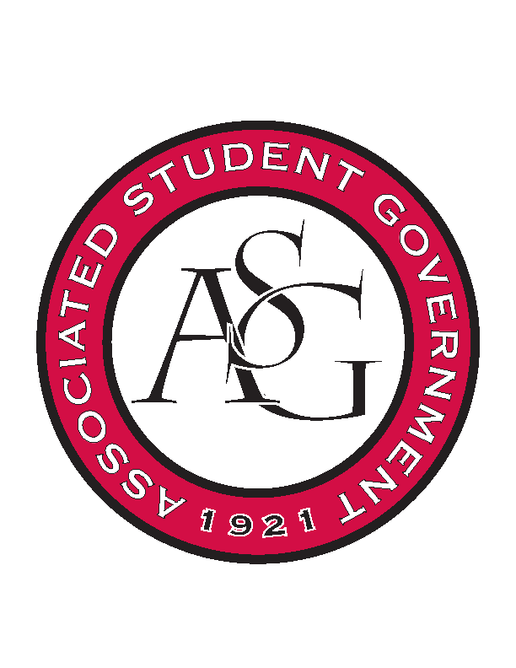
Associated Student Government

Office of Financial Affairs Meeting Agenda
November 16, 2017

- Call To Order 5:02pm
- Roll Call
a. Adam Jones
b. Andrew Estes
c. Colin Gonzalez
d. Jalen Hemphill
e. Kyle Ward
f. Kadarius
g. Peyton Podschwit
Proxy: Ploy
h. Semien Hagos
i. Sofia Hadley
Proxies
j. Kate Hedgecock
k. Madeline Brown
l. William Neely
- Approval of the Minutes
- Appeals
- Audit Reports
- Tabled Budgets
  - Pre-Veterinary Club
      - Second round approved (9-0)
- Old Business
  - Chinese Students and Scholars Association
      - Second round approved (9-0)
  - Arkansas Women in Statistics and Mathematics
      - Second round approved (9-0)
- New Business
  - Alpha Epsilon Delta
      - What time does it end?
      - First round approved (9-0)
  - Printmaking Club – Conference
      - First round approved (9-0)
  - Lambda Alpha Epsilon
      - Need a more detailed list for miscellaneous
      - Per Diem should be $46
      - First round approved (9-0)
  - Printmaking Club – Event
      - Why two nights?
      - First round approved (9-0)
  - Hogs End Alz
      - First round approved (9-0)
- Standing Rules Meeting
  - Recreational and/or leisure events that lack educational value will not be funded
  - Add a question line to HogSync about why two nights are necessary if they ask for more than one
  - Honorarium - $1,500 per semester
  - Changed “encouraged” to “expected” in line 300
      - Standing Rules Approved by OFA Board (9-0)
- Announcements
  - Don’t forget to do audits!
- Adjournment 5:41pm

