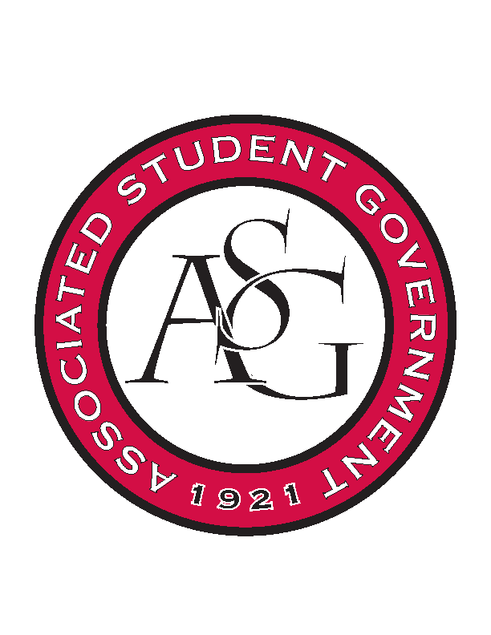
Associated Student Government

Office of Financial Affairs Meeting Agenda
November 2, 2017

- Call To Order- 5:01pm
- Roll Call
a. Adam Jones
b. Andrew Estes
c. Colin Gonzalez
Proxy: Kate
d. Jalen Hemphill
e. Kyle Ward
f. Kadarius
g. Peyton Podschwit
h. Semien Hagos
i. Sofia Hadley
Proxies
j. Kate Hedgecock
k. Madeline Brown
l. William Neely
m. Ploy Pleetissamuth
- Approval of the Minutes
- Audit Reports
  - Kyle Ward – Citizens Climate Lobby
  - Peyton Podschwit – Graduate Students in English
- Appeals
- Old Business
- YOLO Tax Approval 75.64 – approved 9-0
  - Badminton Club
      - Second Round Approved (9-0)
  - Hogs End Alz
      - $83.64 after tax
      - Second Round Approved (9-0)
  - Non-traditional Premedical Student Organization
      - Second Round Approved
  - Association of Ceramic Enthusiasts
      - Second Round Approved (9-0)
  - The Higher Education Organization
      - Second Round Approved (9-0)
- New Business
  - Geo-Institute Graduate Student Organization
      - Board agreed that it sounds like a recruitment event
      - AM or PM?
      - Approved (8-1) – cut down to meet recruitment
  - Korean Food Cooking Club
      - Is this a banquet?
      - Cannot fund appliances
      - What exactly is the $400 for?
      - How will it be educational?
      - We need an approved contact email for vendor – House of Taste
      - Why is catering necessary when you’re cooking?
      - Approved (6-3)
  - Agricultural Communicators of Tomorrow
      - Could not find the registration website – received an email
      - Will actually be $975.00
      - Approved (9-0)
  - Alpha Kappa Psi
      - Approved (9-0)
  - Contemporary Sculpture Society
      - Why are two nights necessary?
      - Where is the guest coming from?
      - Approved (8-1)
  - Students of Retailing Excellence
      - Late
      - Denied (0-9)
- Announcements
  - Don’t forget to do audits!
  - Standing Rules meeting November 9!
- Adjournment – 5:33pm

