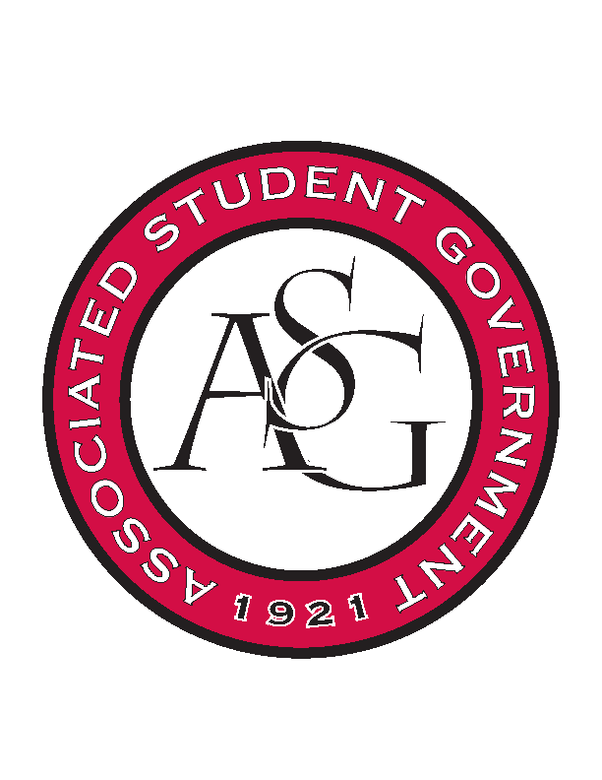
Associated Student Government

Office of Financial Affairs Meeting Agenda
November 30, 2017

- Call To Order
- Roll Call
a. Adam Jones
b. Andrew Estes
c. Colin Gonzalez
d. Jalen Hemphill
e. Kyle Ward
f. Kadarius
g. Peyton Podschwit
h. Semien Hagos
i. Sofia Hadley
Proxy: William Neely
- Approval of the Minutes
- Appeals
- Audit Reports
- Old Business
  - Alpha Epsilon Delta
      - Their event ends at 9pm
      - Second round approved (9-0)
  - Printmaking Club – Conference
      - Second round approved (9-0)
  - Lambda Alpha Epsilon
      - The RSO specified what the miscellaneous items were
      - Second round approved (9-0)
  - Printmaking Club – Event
      - Cutting budget to one night approved (7-2)
      - Second round approved (9-0)
  - Hogs End Alz
      - Second round approved (9-0)
- New Business
  - Biomedical Engineering Society
      - Who is speaking and what are their emails?
      - What’s in the Panera bread box?
      - Is this event only for biomedical students?
      - If not, how will you open it up to other students?
      - Approved (9-0)
  - Chi Epsilon
      - Cut the hotel
      - Approved (9-0)
  - Horticulture Club
      - What are the tools going to be used for?
      - Can all students come and learn something at this event?
      - Will this be educational, or will there only be a cleaning of the greenhouse?
      - Does the university maintain this greenhouse?
      - Change the AM to PM
      - Approved (9-0)
  - Kappa Kappa Psi
      - Approved (9-0)
  - American Constitution Society
      - Why are two nights necessary?
      - Approved (9-0)
- Announcements
  - Don’t forget to do audits!
  - OFA White Elephant
- Adjournment 5:38pm

