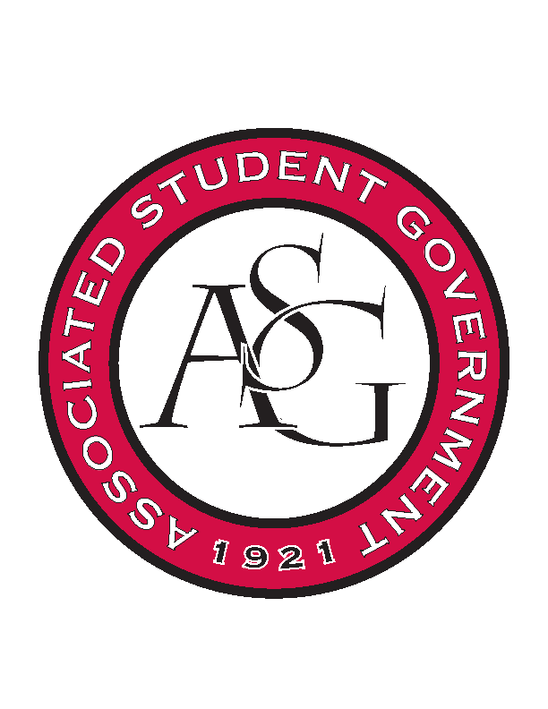
Associated Student Government

Office of Financial Affairs Meeting Agenda
November 9, 2017

- Call To Order 5:01pm
- Roll Call
  - Adam Jones
Proxy: William
b. Andrew Estes
c. Colin Gonzalez
d. Jalen Hemphill
e. Kyle Ward
f. Kadarius
g. Peyton Podschwit
h. Semien Hagos
Proxy: Ploy
i. Sofia Hadley
Proxies
j. Kate Hedgecock
k. Madeline Brown
l. William Neely
- Approval of the Minutes
- Appeals
  - Students of Retailing Excellence
      - Approved (8-1)
- Audit Reports
  - Razorback Booster Club- Homecoming Pep Rally (Izzy Garcia)
  - Native American Student Association- “More Than a World” (Jalen Hemphill)
  - Students for Refugees- “Refugee Round Table” (Colin Gonzalez)
  - Graduate Students in English (Peyton Podschwit)
  - ASCEND- “Dinner with Professionals” (Peyton Podschwit)
- ASG Constitution Committee Nominations
  - Sofia Hadley (9-0)
- Old Business
  - Geo-Institute Graduate Student Organization
      - New Amount $98.79
      - 5:30 AM or PM?
      - Second Round Approved (9-0)
  - Korean Food Cooking Club
      - RSO said it is not a banquet
      - $400 is for utilities and ingredients that the RSO wishes to use for upcoming years
      - OFA will not fund cooking utilities
      - Vote on cutting catering (9-0) approved
      - Vote on approving budget of $78 (9-0) approved
  - Agricultural Communicators of Tomorrow
      - Second approved (9-0)
  - Alpha Kappa Psi
      - Second round approved (9-0)
  - Contemporary Sculpture Society
      - Second round approved with two nights (8-1)
- New Business
  - Chinese Students and Scholars Association
      - Approved (9-0)
  - Arkansas Women in Statistics and Mathematics
      - The website says $86 for the date that they are using
      - Approved (8-1)
  - Reformed University Fellowship
      - Where is the conference?
      - Do you have more than 15 people going?
      - When is the website coming?
      - Denied (8-0-1)
- Standing Rules Meeting
  - All changes for HogSync
  - Budgets are added to the OFA Agenda on Wednesdays at 5pm, anything submitted after will be reviewed in the next meeting
  - For conferences taking place during winter break, RSOs must apply for funding 5 weeks prior to dead day
  - Specify winter break in lines 54-56
  - Under board procedures, all voting activities will follow Robert’s Rules as opposed to “ALL board procedures”
  - Budgets that are denied due to late submissions will not be allowed to appeal
  - Individual Conferences registration fees will only be allocated to students presenting at a conference
  - Absolutely no caned beverages may be purchased through any vendors including Chartwells
  - The RSO can request up to $1,500 honorarium per academic year, up to $750 per event
  - We do not fund parking passes
  - Cannot promote individual businesses
- Announcements 7:58pm
  - Don’t forget to do audits!
  - Funding Session Nov 14
- Adjournment

